**Zadanie 7 – WRED**

**Vladimír Jančich, Roman Kasala**

# Topológia

Dvojica smerovačov prepojená sériovým káblom na rozhraní s0/0/0. Koncové počítače sú k obom smerovačom pripojené na rozhraní fa0/0. IP adresa počítača pripojeného k R1 bola 10.0.1.10/24. Rozhranie fa0/0 smerovača R1 malo IP adresu 10.0.1.1/24. Rozhranie s0/0/0 smerovača R1 malo IP adresu 10.0.12.1/24 a rozhranie s0/0/0 smerovača R2 dostalo IP adresu 10.0.12.2/24. Rozhranie fa0/0 smerovača R2 malo IP adresu 10.0.2.1/24 a počítač pripojený k tomuto rozhraniu používal IP adresu 10.0.2.10/24. Medzi smerovačmi fungovalo jednoduché statické smerovanie a sériové rozhranie bolo limitované na priepustnosť 128 Kbps. Postarali sa o to príkazy clock rate 128000 a bandwidth 128.

**R1**

**R2**

**10.0.1.0 / 24**

**10.0.2.0 / 24**

**10.0.12.0 / 24**

**128 k**

**clock rate**

**bandwidth**

**Sender**

**Reciever, WS**

**S0**

**S0**

**f0**

**f0**

# Zadanie

* Generovať 4 TCP toky (každý 50 kbps) + jeden UDP tok (50 kbps)
* Otestovať rôzne scenáre pre FIFO, CBWFQ, WRED a WRED + ECN
* 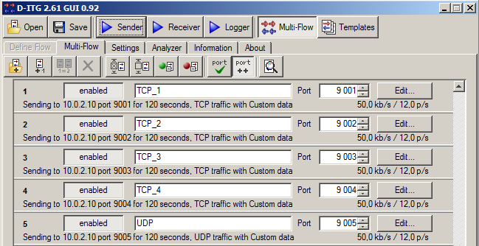Nastaviť značkovanie paketov. Pre TCP toky boli použité značky AF11, AF12, AF31, AF33, a pre jediný UDP tok značka AF21.

# Konfigurácia

*access-list 101 permit tcp any any eq 9001*

*access-list 102 permit tcp any any eq 9002*

*access-list 103 permit tcp any any eq 9003*

*access-list 104 permit tcp any any eq 9004*

*access-list 105 permit udp any any eq 9005*

*class-map match-all tok1*

*match access-group 101*

*class-map match-all tok2*

*match access-group 102*

*class-map match-all tok3*

*match access-group 103*

*class-map match-all tok4*

*match access-group 104*

*class-map match-all tok5*

*match access-group 105*

*policy-map oznac*

*class tok1*

*set dscp af11*

*class tok2*

*set dscp af12*

*class tok3*

*set dscp af31*

*class tok4*

*set dscp af33*

*class tok5*

*set dscp af21*

*interface FastEthernet0/0*

*service-policy input oznac*

*service-policy output oznac*

# FiFo

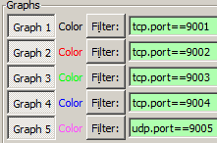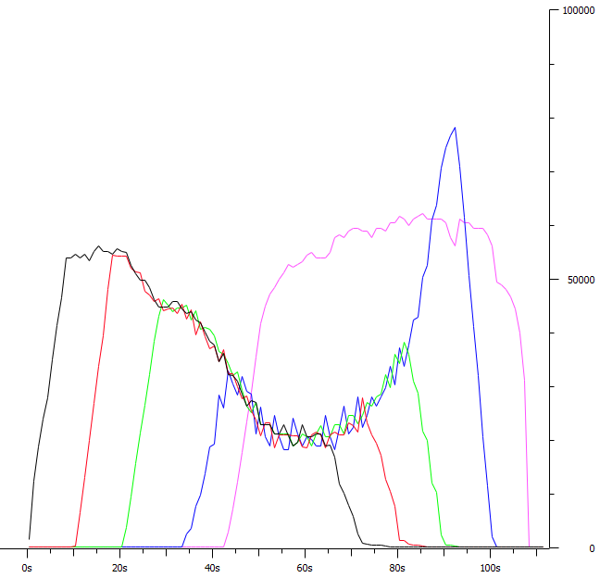

|  |
| --- |
| **TOTAL RESULTS** |
| Number of flows = 5 |
| Total time = 99.614000 s |
| Total packets = 2585 |
| Average jitter = 0.102022 s |
| Delay standard deviation = 1.501295 s |
| Bytes received = 1323520 |
| Average bitrate = 106.291887 Kbit/s |
| Average packet rate = 25.950168 pkt/s |
| Packets dropped = 0 (0.00 %) |
| Average loss-burst size = 0 pkt |

* UDP spapala najviac BW linky.
* Straty boli nulové = 0%.

# CBWFQ

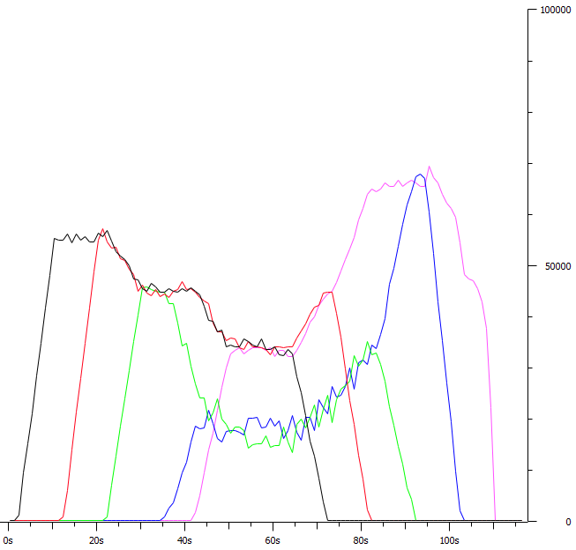

* Vytvorili sme policy-map s názvom CBWFQ
* Vyhradili minimálnu šírku pásma 25% pre triedy
* V class-default sa nachádzal zvyšok prevádzky TCP tok3 a tok4 (AF31 a AF33).
* Konfigurácia:

*policy-map CBWFQ*

*class tok1*

*bandwidth percent 25*

*class tok2*

*bandwidth percent 25*

*class tok5*

*bandwidth percent 25*

*class class-default*

*fair-queue*

*interface Serial0/0/0*

*service-policy output CBWFQ*

|  |
| --- |
| **TOTAL RESULTS** |
| Number of flows = 5 |
| Total time = 109.097000 s |
| Total packets = 2551 |
| Average jitter = 0.317593 s |
| Delay standard deviation = 8.612499 s |
| Bytes received = 1306112 |
| Average bitrate = 95.776199 Kbit/s |
| Average packet rate = 23.382861 pkt/s |
| Packets dropped = 59 (2.26 %) |
| Average loss-burst size = 1.282609 pkt |

* Straty 59 paketov a všetky z UDP toku.

# WRED

* 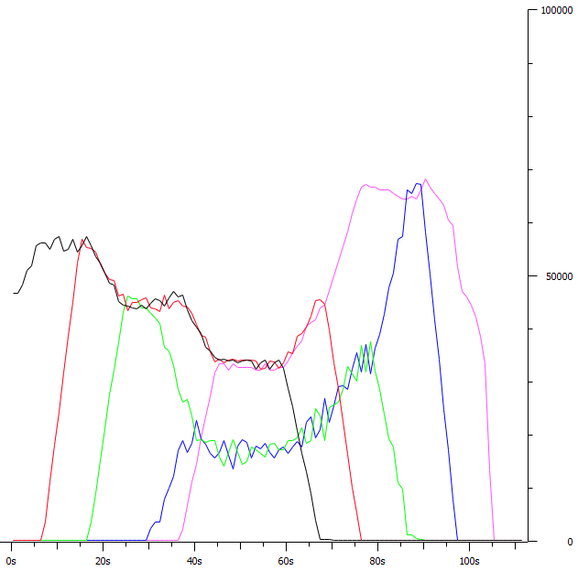Vytvorili sme policy-map s názvom WRED
* Vyhradili minimálnu šírku pásma 25% pre triedy
* V class-default sa nachádzal zvyšok prevádzky TCP tok3 a tok4 (AF31 a AF33).
* Konfigurácia:

policy-map WRED

class tok1

bandwidth percent 25

class tok2

bandwidth percent 25

class tok5

bandwidth percent 25

class class-default

random-detect

interface Serial0/0/0

service-policy output WRED

|  |
| --- |
| **TOTAL RESULTS** |
| Number of flows = 5 |
| Total time = 109.990000 s |
| Total packets = 2602 |
| Average jitter = 0.294617 s |
| Delay standard deviation = 8.617160 s |
| Bytes received = 1332224 |
| Average bitrate = 96.897827 Kbit/s |
| Average packet rate = 23.656696 pkt/s |
| Packets dropped = 57 (2.14 %) |
| Average loss-burst size = 1.390244 pkt |

* Straty 57 paketov a všetky z UDP toku.

# WRED + ECN

* 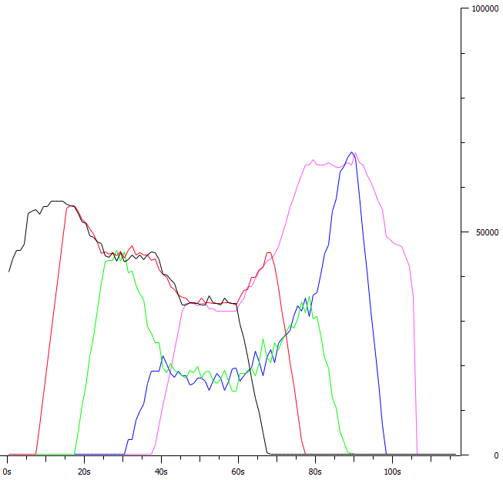Vytvorili sme policy-map s názvom WREDECN
* Vyhradili minimálnu šírku pásma 25% pre triedy
* V class-default sa nachádzal zvyšok prevádzky TCP tok3 a tok4 (AF31 a AF33).
* Konfigurácia:

policy-map WREDECN

class tok1

bandwidth percent 25

class tok2

bandwidth percent 25

class tok5

bandwidth percent 25

class class-default

random-detect

random-detect ecn

interface Serial0/0/0

service-policy output WREDECN

|  |
| --- |
| **TOTAL RESULTS** |
| Number of flows = 5 |
| Total time = 109.990000 s |
| Total packets = 2602 |
| Average jitter = 0.294617 s |
| Delay standard deviation = 8.617160 s |
| Bytes received = 1332224 |
| Average bitrate = 96.897827 Kbit/s |
| Average packet rate = 23.656696 pkt/s |
| Packets dropped = 57 (2.14 %) |
| Average loss-burst size = 1.390244 pkt |

* Straty 57 paketov a všetky z UDP toku.

